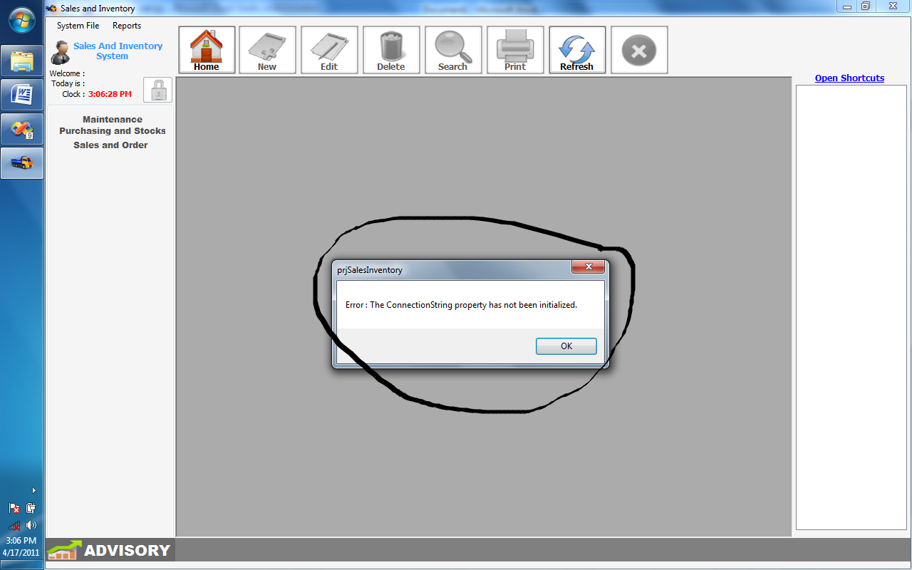
“Error: The connectionString property has not been initialized”
Reasons :
- This mean that you didn’t specify your SQL SERVER NAME

SOLUTION:
- In the server settings, choose between the option “LAN BASE CONNECTION” or “STANDALONE CONNECTION”.

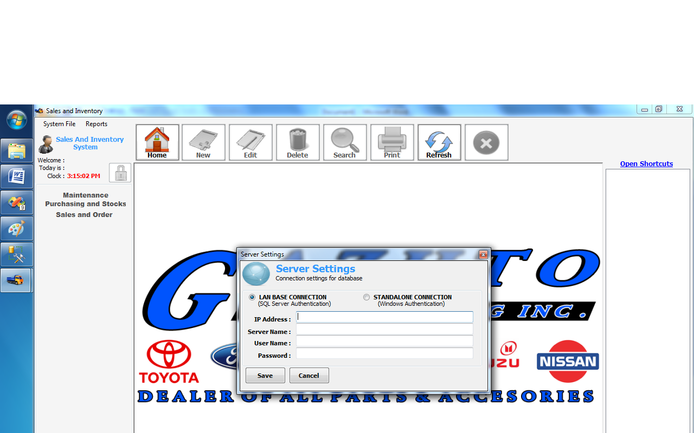

“LAN BASE CONNECTION “
IP ADDRESS(Need to specify)
  - Specify the IP Address where SQL SERVER is located
SERVER NAME(Need to specify)
  - Specify the Server Name where you want to connect to
    - Reason is, because there can be so many SQL SERVER NAME in just one IP ADDRESS , so you will need to specify what is the SQL SERVER NAME you will be connected to..
User Name(need to specify)
  - Specify the User Name of the SQL SERVER
    - Default username of any SQL SERVER IS ‘sa’ which means system administrator..
Password (need to specify)
  - Specify the Password of your SQL SERVER, where you want to connect to..
    - During installation of your SQL SERVER You will be prompt if your SQL SERVER IS in Normal Setup or Mix Mode, Mix mode Setup will ask you a password, that password will be used every time you connect in your SQL SERVER..

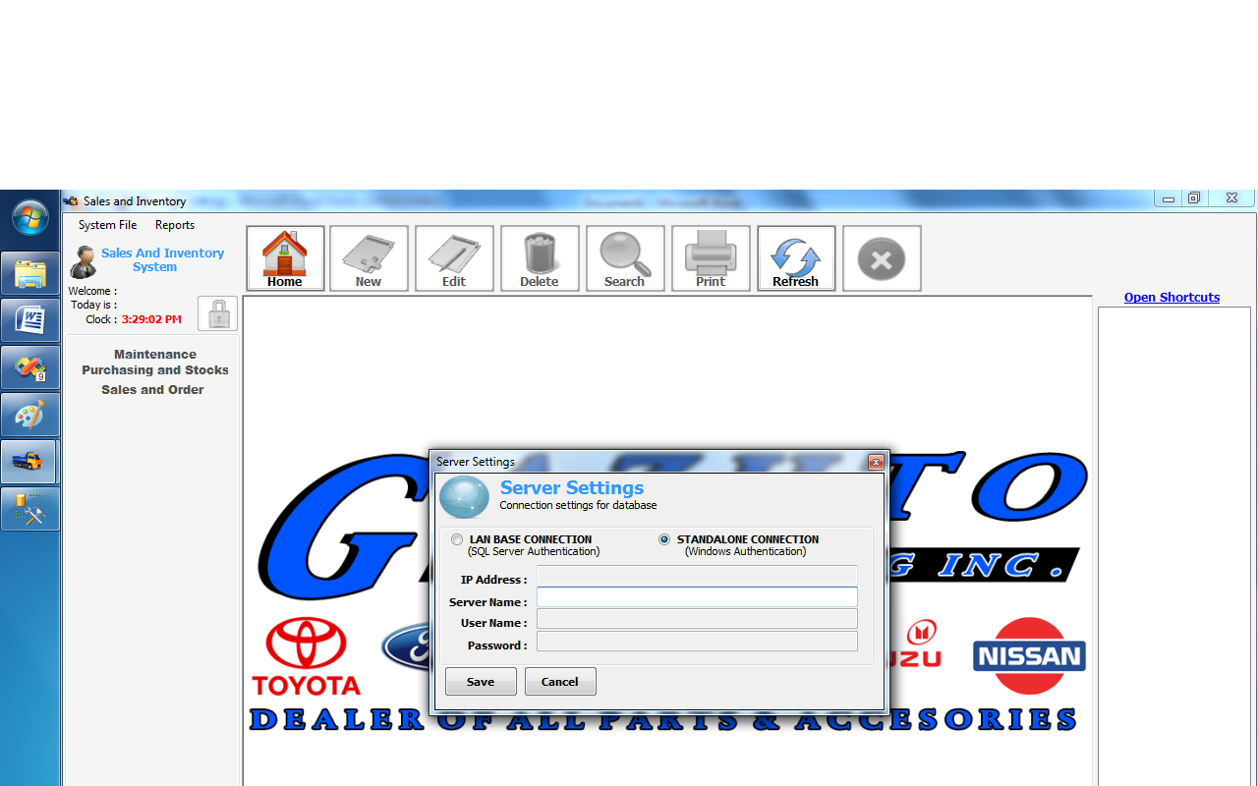
“STANDALONE CONNECTION”
This only require your SQL SERVER NAME

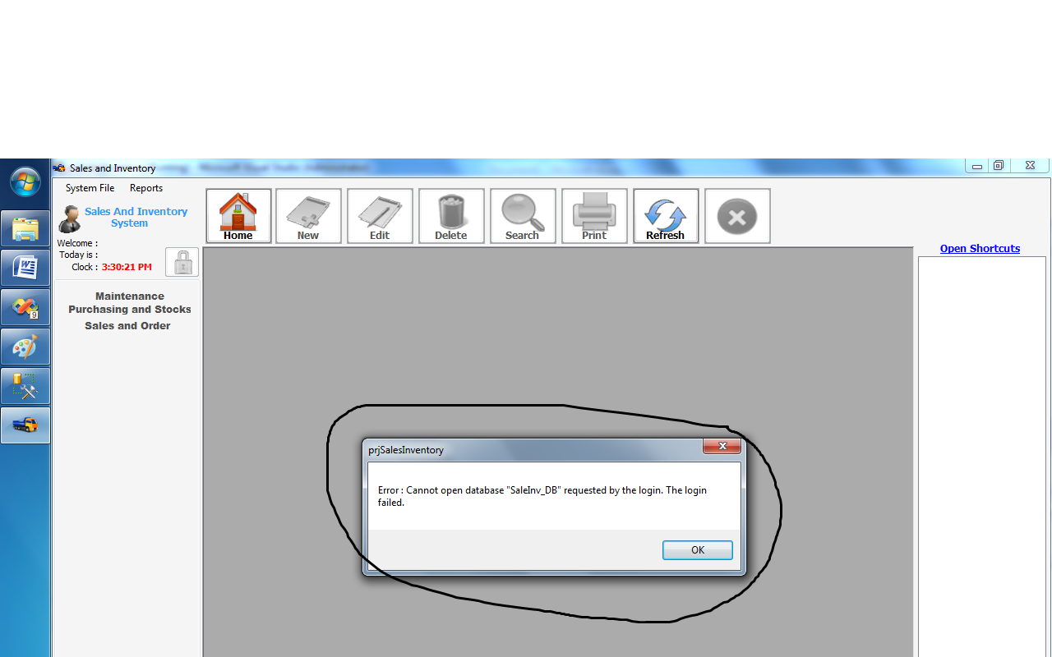

If you encounter this error
“ERROR: Cannot open database “SaleInv_DB” requested by the login. The login failed.

Reason:
  - Probably the sql database SaleInv_DB has not yet been created or attached in the SQL SERVER.

FIX:
  - In the folder _SCRIPTS_SQL_DATABASE there are two folders in there the SQL_SERVER_2005 and SQL_SERVER_2005 select which one is your SQL SERVER, then open the scripts, and execute it.

IT SHOULD BE RUNNING NOW.. THANKS

PLEASE DON’T FORGET TO VOTE!!!

